**CSC462-Artificial Intelligence**

**Project Proposal**

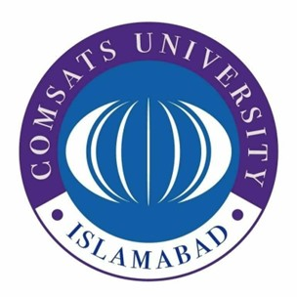

*Comsats University Islamabad, Islamabad Campus*

**Submitted By:**

Muhammad Uzair FA20-BCS-040

Muhammad Atiq Abdullah FA20-BCS-047

**Submitted To:**

Mam Shahela Saif

**Abstract**

This project is an AI based ***Smart Recruitment System***. It is an intelligent system that will help interviewers in choosing the best applicant for their company. Benefits of this smart system are:

* Time Saving
* Shortlists top profiles
* A thorough understanding of a person's talents and skills

|  |  |  |  |
| --- | --- | --- | --- |
| **Module/Project Name** | **List of Functionalities** | **Tools/**  **Technology/**  **Languages** | **Group Members Responsible** |
| **Smart Recruitment System**      Assists Interviewer in selecting best candidate | Excel file containing profile links  System will open links, do scrapping and gather required data using Selenium  Using AI Algorithms, system will rank the profiles that are best suitable | SELENIUM for web scrapping  EXCEL for storing data  TKINTER for basic GUI  AI based algorithms for Data Analysis | **Muhammad Uzair**  FA20-BCS-040    **Muhammad Atiq Abdullah**  FA20-BCS-047 |